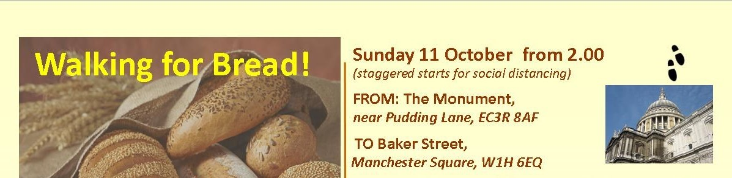

ROUTE GUIDE – ACCESSIBLE ROUTE

- From the Monument, head north up Fish St Hill and turn left (west) into Eastcheap.
- Cross over Cannon St, north side, in several stages, crossing Eastcheap, Gracechurch St and King William St in turn
- After about 400 metres, still on the north side, continue on Cannon St across a major junction with Queen Victoria Street.
- After around 150 yards, reach New Change and St Paul’s Cathedral.
- Keep straight ahead onto St Paul’s Churchyard (a road), with Festival Gardens and the Cathedral on your right.
- Continue along St Paul’s Churchyard westward as it curves right then left into Ludgate Hill.
- Continue with City Thameslink station on your left, downhill to Ludgate Circus. Cross Ludgate Hill and the top of New Bridge St in two stages, onto the south side of Fleet St.
- Continue straight along Fleet St for several hundred yards, until it becomes the Strand.
- Pass the Royal Courts of Justice on your right, then on reaching the Aldwych, cross to the far (west) side of Arundel St, and turn left downhill towards the river. CARE – the pavement is very narrow in sections due to construction hoardings.
- At the bottom of Arundel St, turn right into Temple Place, and follow the road around until it joins the Victoria Embankment.
- Follow the Embankment past Somerset House on your right, and under Waterloo Bridge.
- Shortly after, cross Savoy Place, and immediately turn right into a section of Victoria Embankment Gardens.
- At the end of the Gardens, stay on the left-hand path, and with a café on your left, exit the park via a narrow passage that leads towards Embankment underground station. Don’t return to the main road.
- Keeping the underground entrance on your left, keep straight on past some bollards and under the platforms of Charing Cross mainline station.
- As you emerge from the gloom, turn sharp left, keeping the pedestrian staircase to Hungerford Bridge to your right.
- Soon after, at the Embankment, turn right and cross Northumberland Avenue at the traffic lights.
- Walk ahead down the Embankment and cross Horse Guards Avenue. Continue past New Scotland Yard and towards the Houses of Parliament.
- At the T-junction with Bridge St, turn right, keeping Portcullis House to your right.
- After around 100 yards, cross Parliament St and continue straight ahead into Great George St, with the Treasury buildings on your right.
- At the next junction, with Horse Guards Road, cross straight ahead at the lights and into Birdcage Walk.
- Shortly after the junction, there’s an entrance to St James’s Park, with an information board. Turn right into the Park, and head towards the lake and fountain.
- Follow the path as it curves to the left to run along the south side of the ornamental lake.
- After around 400 yards, turn right across the pedestrian ‘Blue Bridge’.
- Across the bridge, turn left (west) and follow the path keeping close to the north side of the lake, with Buckingham Palace ahead of you.
- Towards the end of the lake, keeping a wooden booth to your left, head right and uphill around 150 yards to the Mall, and cross at the pedestrian lights.
- Cross into Green Park – the level route is to the right of the monumental, curved and raised flowerbeds.
- Then bear left, keeping the flowerbeds to your left, and onto Constitution Hill. Follow the broad track slightly uphill for around 800 metres, always keeping the main park on your right, until you reach Duke of Wellington Place.
- Cross the gyratory at the traffic lights, and go through the ceremonial arch, then head northwest and cross the gyratory again, and then Knightsbridge (eastbound), to go under the left-hand arch, with Aspley House to your right.
- Cross South Carriage Drive and a dedicated a cycle lane at the pedestrian crossing, and into Hyde Park proper. Turn right and head for a metal road barrier blocking vehicle access.
- Keep this to your right, then head north, with a monumental statue and Park Lane to your right.
- Take the Broad Walk, the right-most tarmac mixed-use path which runs all the way along the eastern side of the park to Marble Arch.
- As you approach the north side of the park, stay straight ahead where the main path branches left, heading instead for Marble Arch.
- At the Marble Arch gyratory, use the pedestrian crossing to your right to cross the northbound Park Lane, then head towards the Arch, also crossing Cumberland Gate and onto the island with the arch itself.
- Cross the island and exit to the north across Marble Arch (a road) and into Great Cumberland Place. Use either the dedicated cycle crossing point, or head a little to the right to cross into Cumberland Place in two stages. CARE: there may be roadworks in Cumberland Place.
- Continue north up Cumberland Place, preferably on the right/east side, and turn right into Seymour St for around 150 metres, where you join the south side of Portman Square.
- Continue along the south side of the Square and turn north along the east side of Portman Square.
- At the next junction, you have reached the southernmost point of Baker St, and the formal end of the walk. Congratulations!
- Then turn right across Baker St and into Fitzhardinge St, and continue to Manchester Square. Head left/north to the Wallace Collection building, to hand in your quiz answers to one of the organisers.

