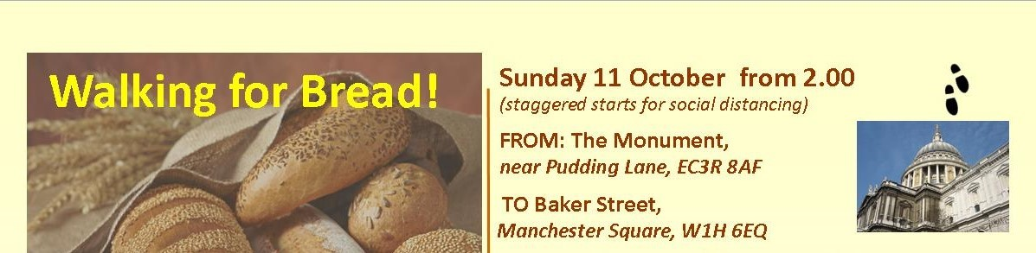

ROUTE GUIDE – MAIN ROUTE

- From the Monument, head north up Fish St Hill and turn left (west) into Eastcheap.
- Shortly after, cross the junction using the subways, and into the north side of Cannon St.
- After about 400 metres, turn right (north) into Queen’s St – pedestrianised at this stage.
- After about 25 metres, you reach Queen Victoria Street. Cross to the north-west to join the start of Watling St. (now semi-pedestrianised).
- After about 300 metres, reach New Change and St Paul’s Cathedral.
- Cross the road with care and keep straight ahead into Festival Gardens, keeping to the south of St Paul’s.
- Walk through the Gardens following the perimeter of the Cathedral, and join St Paul’s Churchyard (a road) near the south entrance to the Cathedral.
- Continue along St Paul’s Churchyard westward as it curves right then left into Ludgate Hill.
- Continue with City Thameslink station on your left, downhill to Ludgate Circus. Cross Ludgate Hill and the top of New Bridge St in two stages, onto the south side of Fleet St.
- After 30 metres, turn left into Bride Lane, then right up some stairs into St Bride’s Avenue. Then turn right again to re-join Fleet Street, where you turn left to head west again.
- Continue straight along Fleet St for several hundred yards, until it becomes the Strand.
- Pass the Royal Courts of Justice on your right, then turn left just beyond the George pub into Essex St.
- At the end of this street, descend steps into Milford Lane, and follow the lane towards the river to Victoria Embankment Gardens.
- Walk through the Gardens to join the Victoria Embankment proper. Follow the Embankment past Somerset House on your right, and under Waterloo Bridge.
- Shortly after, cross Savoy Place, and immediately turn right into a second section of Victoria Embankment Gardens.
- At the end of the Gardens, stay on the left-hand path, and with a café on your left, exit the park via a narrow passage that leads towards Embankment underground station. Don’t return to the main road.
- Keeping the underground entrance on your left, keep straight on past some bollards and under the platforms of Charing Cross mainline station.
- As you emerge from the gloom, cross Northumberland Avenue directly (with care) and into Whitehall Gardens.
- Walk down the Gardens, and at the southern end, leave by some steps, and cross Horse Guards Avenue. Don’t return to the main road.
- Continue into the confusingly-named ‘Victoria Embankment Gardens, Whitehall Extension’.
- Take the right-hand path, passing numerous military memorials, and at the right-hand corner of the Gardens, turn right into an unnamed pedestrian lane, with the MoD to your right, and New Scotland Yard carpark to the left.
- After about 200 yards, reach Whitehall and turn left towards the Cenotaph.
- Just past the Cenotaph, at the first pedestrian signal, cross the main road (now Parliament St) and go through an arch into King Charles St.
- At the end of the street, descend a grand flight of steps and cross (with care) Horse Guards Road into St James’s Park.
- Proceed straight ahead, such that the ornamental lake stays to your immediate right.
- After around 400 yards, turn right across the pedestrian ‘Blue Bridge’.
- Across the bridge, turn left (west) and follow the path keeping close to the north side of the lake, with Buckingham Palace ahead of you.
- Towards the end of the lake, keeping a wooden booth to your left, head right and uphill around 150 yards to the Mall, and cross at the pedestrian lights.
- Cross into Green Park – the level route is to the right of the monumental, curved and raised flowerbeds.
- Then bear left, keeping the flowerbeds to your left, and onto Constitution Hill. Follow the broad track slightly uphill for around 800 metres, always keeping the main park on your right, until you reach Duke of Wellington Place.
- Cross the gyratory at the traffic lights, and go through the ceremonial arch, then head northwest and cross the gyratory again, and then Knightsbridge (eastbound), to go under the left-hand arch, with Aspley House to your right.
- Cross South Carriage Drive and a dedicated a cycle lane at the pedestrian crossing, and into Hyde Park proper. Turn right and head for a metal road barrier blocking vehicle access.
- Keep this to your right, then head north, with a monumental statue and Park Lane to your right.
- Take the Broad Walk, the right-most tarmac mixed-use path which runs all the way along the eastern side of the park to Marble Arch.
- As you approach the north side of the park, stay straight ahead where the main path branches left, heading instead for Marble Arch.
- At the Marble Arch gyratory, use the pedestrian crossing to your right to cross the northbound Park Lane, then head towards the Arch, also crossing Cumberland Gate and onto the island with the arch itself.
- Cross the island and exit to the north across Marble Arch (a road) and into Great Cumberland Place. Use either the dedicated cycle crossing point, or head a little to the right to cross into Cumberland Place in two stages. CARE: there may be roadworks in Cumberland Place.
- Continue north up Cumberland Place, preferably on the right/east side, and turn right into Seymour St for around 150 metres, where you join the south side of Portman Square.
- Continue along the south side of the Square and turn north along the east side of Portman Square.
- At the next junction, you have reached the southernmost point of Baker St, and the formal end of the walk. Congratulations!
- Then turn right across Baker St and into Fitzhardinge St, and continue to Manchester Square. Head left/north to the Wallace Collection building, to hand in your quiz answers to one of the organisers.

