MINUTES of Kennington-Bethlehem Link AGM Monday 2 November 2020
Monday 2 November 2020 - Online ZOOM meeting, thanks to Ursula
Present: Pat Gaffney, Patrick Tatham, Miranda Townsend, Steve Adamson, Mark Kerr-Sheppard, Gill Lucas, Ursula Ovenden, Stephen Mitchell
Apologies: Rachel Philips, Suzette Aagaard, Sue Codrington,
Agenda
- Welcome and minutes of last meeting. Special welcome to two newcomers, Mark and Stephen.
Minutes of the AGM on 4 November 2019 were affirmed by Patrick Tatham as a faithful record of that meeting
- Overview of the past year. Pat presented the work – see slide below. All agreed that we have managed to achieve a great amount given the constraints of 2020 COVID.
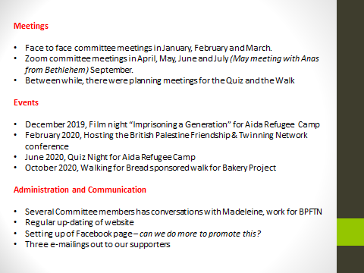

- Finance Report given by Patrick Tatham
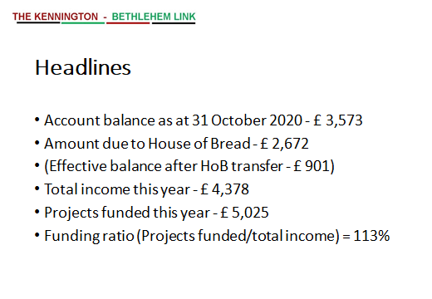

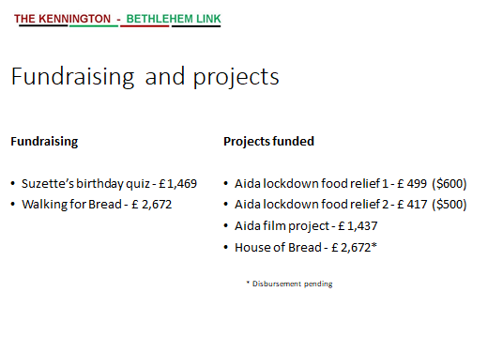

Comments/discussion with Patrick: First two Aida projects came out of 2019 income. Total (non-project) expenses so far this year £224, of which 56% bank charges (£126) Expenses to income ration good, however perhaps need to look at our general resources – try to maintain a balance of around £1000. This could include deducting costs from future project payments. Questions raised about Bank Charges and GoFundMe platform charge. Patrick reported that having looked at alternatives the charge with Unity is pretty standard. The GFM platform charge of 7% is also reasonable.
More general income could be generated by annual subscriptions. Currently there are 8 people paying subscriptions. It was agreed to increase the sub to £10.00 rather than £5.00. The sub year to operate within the calendar year.
Patrick was thanked for the good stewardship of our resources.
Actions:
- PG to make necessary amendment to Constitution
- PT to send bank details to Mark and Stephen

Other items
Discussion on use of term ’Friendship’ in our title. This matter, introduced by Miranda, had been discussed at the September meeting and brought again to this meeting for wider airing. Miranda explained that she felt strongly that the use of the term would better define our relationship with Bethlehem and that it adds meaning to those we work with. It is commonly used in the BPFTN. Several members responded that our title clearly implies friendship and that adding the word would add little value. It would also be a pity to lose the association that people have developed with the title – through our promotion/website/FB. There was no agreement to add Friendship. As a matter of information, Miranda will sound out the BPFTN meeting later this week on the value/use of the term.
Action: Miranda to share response from BPFTN
Update on Bakery Project. Steve reported conversations with Rami who is delighted with our efforts in Walking for Bread. Rami hopes to use the model with contacts in the USA and Germany, to encourage similar projects. Our resources can be shared with Rami. Steve mentioned possibility of creating a video about the walk project for Rami.
To date donations stand at £3,450 and Miranda indicated that there may be more to come from her walk. PG has written to thank all those who took part, sending link to images. SA has emailed all those who have made donations to thank them.
Action: SA will try to download email contacts from GFM page so that we can keep them up-to-date on the project
Ideas for future projects.
Building on success of Walking for Bread, SA and PT have been discussing the idea of a ‘Kennington Bake Off’, possibly something for the Spring. To involve local people/ shops… displaying their wares at a ‘taste off’, possibly in St Anselm’s Church? Charge to take part and possibly entry fee? Also need to consider risk assessment for such a venture. Mark has offered to help here when needed – he takes care of COVID RA in his professional work.
Action: SA and PT to sound out Suzette about the possibility and come back with some suggestions
A lockdown/pre-Christmas project , was suggested by Gill, more as a way of keeping people together/lifting spirits. Could be a different kind of ZOOM Quiz or something similar – not to replace any larger quiz we may undertake in 2021. Thought to be a good idea.
Action: GL/SA and SM agreed to think of how this might be taken forward
Learning from / sharing with other groups in the Network. Patrick introduced this saying there would be great value in such sharing. KBL has good links with Hanwell but there are many more. MT is on the Board of BPFTN and receives regular reports from them. PG send regular up-dates to Madeleine who coordinates this work. We could perhaps look at a ZOOM gathering with a couple of other groups?
Action: (Since our meeting, I have circulated a link to all of you that might help with this – a closed FB group to share information/ideas/project)
Membership of Management Committee
Pat, Stephen and Patrick willing to carry on in current roles. Mark Dickens and Stephen Hoare have resigned. In spite of several contact emails/calls no response this year from Pauline and little contact with Steveland. Agreed that we would keep them on the contact list as members of KB rather than on the Management Committee.
Ursula, Mark and Stephen were invited to join the Committee (and Sue, in her absence… we hope she will join too?) Mark agreed to take on the role of Secretary and asked for an outline of the role.

Committee now as follows (maximum 12 members)

Stephen Adamson – VC
Suzette Aagaard
Sue Codrington
Pat Gaffney, Chair
Mark Kerr-Sheppard, Secretary
Gill Lucas
Stephen Mitchell
Ursula Ovenden
Rachel Phillips
Patrick Tatham, Treasurer
Miranda Townsend

Action: PG to contact Sue and send role outline for Secretary to Mark

Future meetings
These will continue on ZOOM. Suggested that we invite Rami to join our next meeting to up-date us on the Bakery Project and what is happening in Bethlehem. Date set for the meeting is 30 November ( time to be agreed to Rami
Action: Steve to check this out with Rami.
Other up-dates
- Rami has a new job, working with the YMCW in East Jerusalem which will involve working with young people who have been in military detention.
- Steve asks that we remember the Aida Camp and others coping with the new phase of COVID 19. PG reported that she tries to post up-dates from the Aida project on our FB page so people can find out more there.
- Miranda reported that she is keeping Flo Eshalom, Labour MP for Lambeth, informed about the work and focus on the Link. She receives standard replies, Flo is overwhelmed at present with work around violence to women under COVID
- Pat reported that PSC are calling for a Day of Action for Palestine on 28 November, asking groups to do what they can. See link https://www.facebook.com/events/4415342541871695/
- The London Palestine Film Festival begins soon. Link https://www.palestinefilm.org.uk/
Taken by Pat Gaffney
November 2020

